**SPH3U 13.1 Electromagnetic Induction**

1. **Discovery**

|  |  |
| --- | --- |
| Induction: |  |
| Chapter 12: |  |
| Chapter 13: |  |
| stationary magnet |  |
| moving magnet |  |
| Law of electromagnetic induction: |  |

|  |  |
| --- | --- |
| Faraday’s ring: |  |

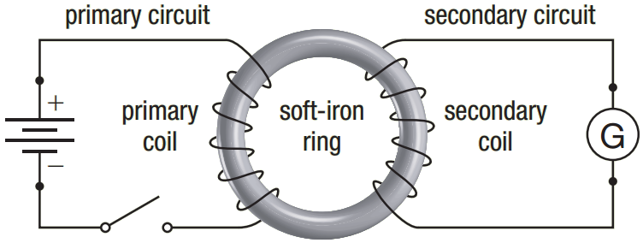

1. **Factors affecting induction**

|  |  |
| --- | --- |
| Coiled conductor: |  |
| Number of loops: |  |
| Change in magnetic field: |  |
| Magnetic field strength: |  |

1. **Applications of electromagnetic induction**

|  |  |
| --- | --- |
| Induction cooking: |  |
| Metal detectors: |  |
| Induction chargers: |  |

**Homework:** page 591: #2-3